# Sprint 2- Creating ERD diagrams

**Topic Picked** – Health

**Primary Database picked**- USDA National Nutrient DB (<https://data.world/craigkelly/usda-national-nutrient-db> )

**Reasons for picking** – The Database we chose contains the nutritional value of over 8000 items consumed in the US. The nutritional value of the items we eat is a significant determining factor of our health and well-being. By analyzing this Database, we can optimize our daily diets to have the perfect combination of nutrients. We can also prescribe special diets for people with diabetes, high blood pressure, or other conditions that still require essential nutrients. Furthermore, we can also find out and avoid unhealthy substances with high fat or sugars and avoid them. For these reasons and more, we are interested in working with the nutritional Database.

**How we shall build the Database** – We shall build the Database by first grouping the closely related data into single tables; for example, we shall group the multiple vitamin data into a single vitamin entity. Then we shall check the relationship between the multiple entities we decided, like one-to-many, one-to-one, etc. Following this, we shall segregate the data into entities by separating them into sheets in excel and then load it into the SQL database

**Entity list –**

1. Food ID and description
2. Common name
3. Manufacturing name
4. Scientific name
5. Nutrient Deficiencies
6. Prominent deficiencies by country
7. Food group
8. Diets and food preferences
9. Nutrients contained (Associative entity)
10. Nutrient list
11. Country Deficiency relationship (Associative entity)
12. Diet-Food combinations (Associative entity)

**(P.T.O)**

**Relationship between Entities** –

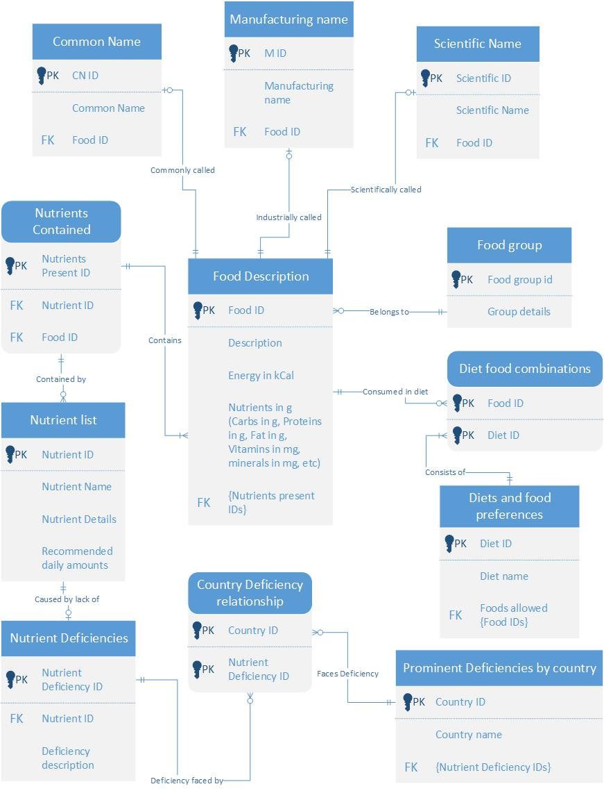

**Scenario for assembling the data** – We are professional dieticians who would like to design proper diets for people with conditions like diabetes, hypertension, etc., and would like a database with the nutritional values of the products so that we may provide diet plans ideally suited to the patient/customer.

**Reports to generate from the Database** –

* Find the protein-by-carbohydrate ratio of natural foods vs. manufactured foods
* Find the % recommended vitamins and minerals found in natural food vs manufactured goods
* Find the food items with the lowest kilo-calorie energy but satisfying most of the recommended vitamin and mineral percentages.